Booking Children in for Casual Days (EXISTING FAMILIES)
Once a child is enrolled at a service, they are able to book in for Casual Days.
To do this the parent will click on the + button in the Casual Bookings section of their dashboard.
The parent will then be presented with a screen where they can select the child, service and room that they are looking to book their child into. The parent will only be able to book in to services that they have associated their child with.
Once an appropriate Child Name, Service name and Room name have been selected, the parent will be presented with the following screen:
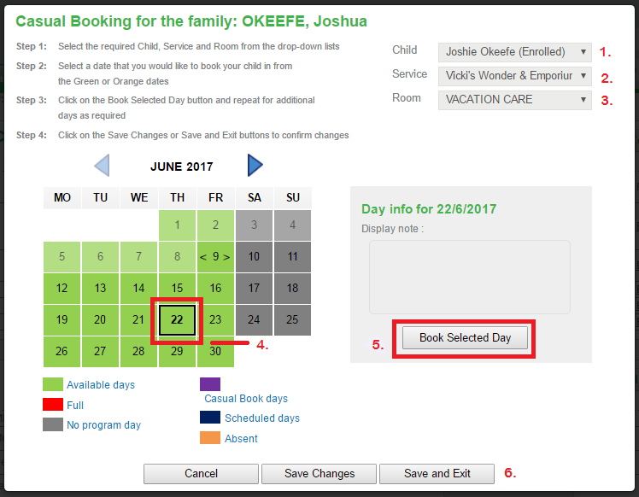
By following steps 1 to 6 the parent will be able to book in casual days at the service, which will automatically create casual roll entries in QikKids linked to the standard casual fee schedule.
Step 1. Select Child
Step 2. Select Service
Step 3. Select Room
Step 4. Select Day required
Step 5. Select booked selected day (repeat step 4 & 5 to book another day)
Step 6. Select Save changes if you want to book in another child
Select Save and Exit to finish making a casual booking
N.B. Once the bookings are confirmed they will appear in purple

