For New families registering
New families will go through the normal registration process for My Family Lounge by clicking on the Register button on your website. This will be done by Inserting the My Family Lounge login feature QK Enrol - user guide on your website.:
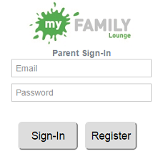
The Parent will then be taken through the registration tool where they will complete information on themselves and then information on their child.
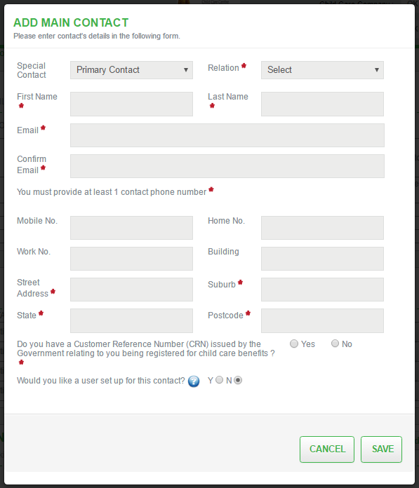
When they reach the Add Child Details screen, they will be asked to select from the options indicated below:
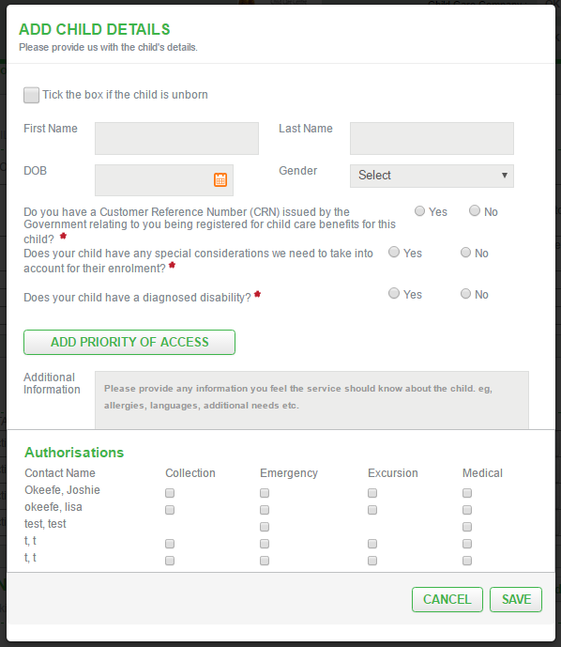
Option 1: Request permanent bookings for my child/ren
This will take the parent to the normal enrolment process where they will request permanent reoccurring days for their child. Once apprpoved by the service the parent will accept the Offer presented and will complete and submit their child enrolment form to confirm the booking.
Option 2: Making a casual booking
This option will take the Parent to the Parent Dashboard where they can immediately complete an enrolment form for their child and look to book the child in for casual days
(Enrolment form MUST be completed and submitted first).
Option 3: Finish registration without saving information which I just entered.
This option will take them to the Parent dashboard however will not save the child information.

Completing an enrolment form
Where a Parent has selected for their child to be booked for Casual days, they must complete and submit an enrolment form. If they try to immediately create the Casual Booking by clicking on the + button as described in the next section, they will receive this message asking them to submit an enrolment form where required.
The Parent should then click on the Finish Enrolment button next to their Child's Name, complete the form and submit. The service will then receive an email notification of this enrolment and the parent will then be able to book in for casual days.
